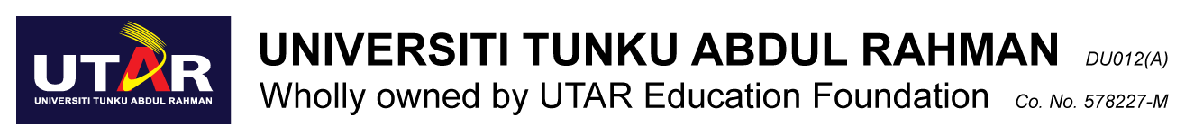

MENTAL AND PHYSICAL HEALTH AWARENESS AWARD
2022 / 2023

APPLICATION FORM

Please fill out the form according to the guidelines below:
Attach your photo here
- Handwritten forms need to be filled out neatly and clearly readable. Printed format is preferred.
- Please attach all relevant documents/evidence of your achievements (i.e. certificates, reports)
- Each candidate is only eligible to win one award.
- The decision of the judging panelists are final and no correspondence will be entertained.

APPLICANT’S PARTICULARS

Name | : |  |  | Student ID | :
IC/Passport No | : |  |  | Faculty | :
Contact Number | : |  |  | Course | :
Email Address | : |  |  | Year / Sem | :

SECTION A: IMPACT
Please identify your MOST impactful project / initiative directly relevant to your category of submission completed during the assessment year (1 April – 31 March). You are required to attach relevant activity and financial reports for the projects / initiatives submitted.

Project / Initiative Name / Title | :
Full name of the Student Body / Organisation represented
Position / Role | : |  |  | Level / Scope | :
Full title of position held |  |  |  | University / National / International
UTAR CARE Hours : Please attach your latest UTAR CARE report

Achievements / Impact (Itemized) | :
You may be required to provide sufficient evidence for achievements declared .
Please consult DSA if you may need further clarification.

DECLARATION

I hereby declare that all information submitted with this application is accurate and true, failing which I may be subject to disqualification if any of my declarations made are found to be fabricated, amended or invalid in any way. I shall respect the decision of the panel with regards to the outcome of the results.

Witnessed / Received By,

______________________________ ___________________________ ________________
Name : DSA Staff PIC : Stamp
Date : Date :

